**Submitted By: Vishnu Deshpande  
----------------------------------------------------------------------** Problem Statement:-

1. Zomato has recruited you as a consultant data analyst, and the team is searching for ways to grow and add new restaurants. It is your responsibility to create plans or ideas for opening more recent eateries.

Objective Questions

**1. The data consists of some inconsistent and missing values so ensure that the data used for further analysis is cleaned.**

**Method used for missing values & cleaning the data:**

* **Conditional Formatting: -** Since there are missing values in the given data, I chose the Raw Data Table, went to the Home tab, applied Conditional Formatting, highlighted cells rule, selected more rules, formatted just cells, selected Blanks and custom with color, and discovered missing values in the Cuisines column.
* **Find & Replace data: -**  Since there were missing values in the given data, I applied a filter to the Raw Data Table, chose the column name Cuisines, and then selected Blank to fill in the blank cells. I then used the average of the values to replace the blank columns with "North Indian."
* **Formatting of Date Column -**Datekey_opening - The date is not formatted appropriately in this column. The formula used here to format the date is =DATEVALUE (SUBSTITUTE (V2,"_","-",)) - Date modified from (2019_9_21) to (21-9-2019) using this formula.

Subsequently, I have taken three additional columns out of the date key starting column. DAY, MONTH, and YEAR are the three new columns.

The formula for DAY is =TEXT (V2, DD").

The formula for MONTH is =TEXT (V2, MM").

The formula for YEAR is =LEFT (U2, 4).

* **Border** - Since there were no borders on the data that was supplied, I created some to make the data seem nice.

**2. Using the LOOKUP functions, fill up the countries in the original data using the country code.**

**Function used for extracting country from the country code:**

* **VLOOKUP Function** - Since the country code is a shared variable between the raw data sheet and the country description sheet. As a result, I looked up the value in a vertical column using VLOOKUP.
* Using the formula =VLOOKUP (C2,'country description')!$A$2:$B$16,2,0
* The country code that has been chosen for searching is C2.
* Description of the country!$A$2:$B$16 is the range in which the code is going to be looked up.
* 2 - The nation will be searched for in this column.
* 0: This indicates the kind of match. Additionally, zero denotes an exact match.

**3. Create a table to represent the number of restaurants opened in each country.**

**Function used to here to count the restaurants opened in each country:**

* **Pivot Table** - As requested by the question, make a table and list the number of restaurants in each nation. We must count the number of restaurants for this, thus I created a pivot table where I sorted by count using the data for Restaurant ID and Country in rows.

**Pic of Pivot Table shown in below:-**

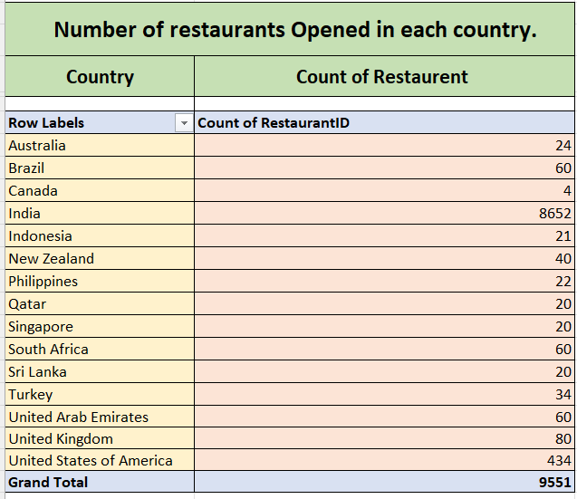

**4. Also the management wants to look at the number of restaurants opened in each year, so provide them with something here.**

**Function used to here to count the restaurants opened in each Year:**

* **Pivot Table** - As requested by the question, make a table and list the number of restaurants in each nation. We need to count how many restaurants open each year, so I created a pivot table with the year in rows and the restaurant name in values, then sorted by count.
* **Pic of Pivot Table shown in below:-**

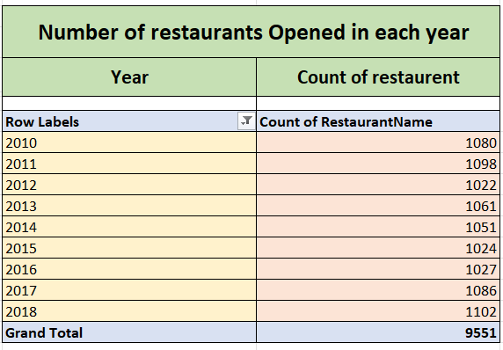

 **5. What is the total number of restaurants in India in the price range of 4?**

**Function used here to count total restaurants in India in price**

**Range of 4:**

* **Pivot Table** - As the question ask to show no. of restaurants in India in price range of 4.Therefore I have used Pivot table in which I take Country and Price Range in Filter and Restaurant Name in values and sort by Count.

**Pic of Pivot Table shown in below:-**

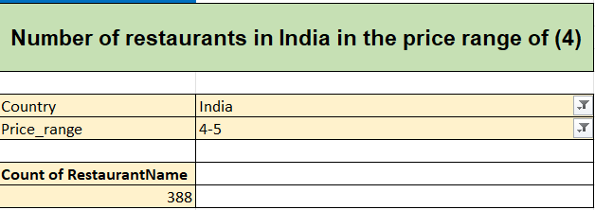

**6. According to the data what is the average number of voters for the restaurants in each country?**

**Function used here to average number of voters for the restaurants in each county.**

**Pivot Table** - The average number of voters for each restaurant in each nation is asked in the question. As a result, I utilized a pivot table, sorting by average after taking the values of the votes and the country in a row.  
  
**Pic of Pivot Table shown in below:-**

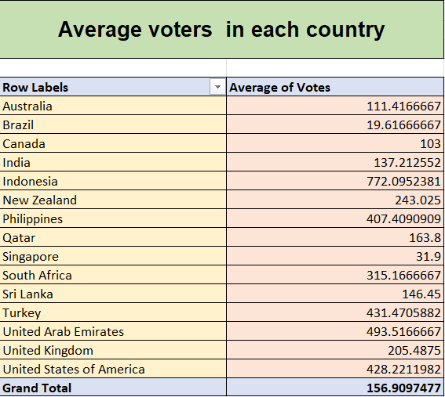

Subjective Questions

**1. Suggest few countries where the team can open newer restaurants with lesser competition. Which visualization / Technique will you use here to justify the suggestions?**

* **Method used:** I've used a pivot table, where I've sorted by count for the restaurant name, value sorted by row for the nation, and average value sorted for the rating. I would choose fewer restaurants after making the pivot table because I want to choose nations where there is less competition and fewer eateries.
* **Analysis:** Following my observations, I would recommend nations with average ratings that are subject to less competition. The average rating was chosen since lower ratings would indicate dissatisfaction with the eateries among the populace in that nation. And this may work to our benefit since we could study the market to find out why customers aren't as content, then concentrate on those issues when the restaurant opens.
* **Countries Suggested for opening new restaurant** :

CANADA, PHILIPPINES, SINGAPORE, SRI LANKA.

* **Location** -

          Excel file - sheet name - **4) Subjective-Analysis 1-4**

Table - **1) Analysis of Countries with lesser competition**

* **Visualization method used**: - Column chart shown below.

**2. Come up with the names of States and cities in the suggested countries suitable for opening restaurants ?**

**Method used:** Using a pivot table, I was able to arrange the restaurant name by value and sort by count, the city in row, the nation in filter, and the rating in value and sort by average.

* **Country - City selected :**

**CANADA** – Yorkton  
**PHILIPPINES** – Santa Rose

**SINGAPORE** - Singapore

**SRI LANKA** - Colombo

* **Location** -

 Excel file - sheet name - **4) Subjective-Analysis 1-4**

 Table - **2) Name of Cities in the suggested countries.**

* **Visualization method used**: - Column chart shown below.

**3. According to the countries you suggested, what is current quality regarding ratings for restaurants that are opened there?**

**Method used: -** Using a pivot table, I rank each nation by value and arrange them in descending order of average.

**Country with Average Rating:-**

CANADA – 3.30  
PHILIPPINES – 3.80

SINGAPORE – 3.58

SRI LANKA – 3.87

**Location:**

 Excel file - sheet name - **4) Subjective-Analysis 1-4**

 Table - **3) Suggested country with rating**

* **Visualization method used**: - Bar chart shown below.

**4. Also what is the current expenditure on the food in the suggested countries, so that we can keep our financial expenditure in control?**

**Method used: -** I've used a pivot table, where I sort by average after taking the average cost of two values per nation in a row.

**Current Expenditure on Food:**

Canada – 25.00

Philippines- 825.00

Singapore – 155.75

Sri Lanka – 2375.00

**Location:**

           Excel file - sheet name - - **4) Subjective-Analysis 1-4**

Table - **4) Total expenditure on food**

**Visualization method used**: - Column chart shown below

**5. Come up with the names of restaurants from the recommended states that are our biggest competitors and also those which are rated in the lower brackets, i.e. 1-2 or 2-3?**

**Method used:** For this question, two pivot tables have been employed. I use the restaurant name in a row, the nation and city as a filter, the rating as a value, and average sorting in the first pivot. I put the restaurant name in row and the rating and city in the filter of my second pivot table. The rivals are rated and assessed accordingly.

* **Restaurants who are biggest competitors:** They are marked in the excel file with a yellow hue. Due to their highest ratings, these competitors are the largest.

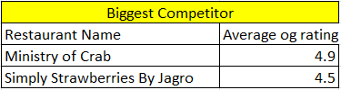

* **Restaurants which are rated low**: are indicated in the Excel file with an orange color. The least desirable rating range.

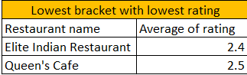

* **Location -**

           Excel file - sheet name - **5) Competitor-Analysis**

**6. Which cuisines should we focus on in the newer restaurants to get better feedbacks? Does the choice of cuisines affect the restaurant ratings?**

**CUISINES TO FOCUS** - Indian, Mediterranean, American, Asian, Pizza, Italian, Filipino, Japanese, Korean, Sushi, and Steak.

**The choice of cuisines -** Influence the rankings as each nation has its own regional dietary habits and choices. For instance, selling food abroad would not result in the same sales volume as selling it domestically in Canada.

* **Basis for suggestion** - The foundation I've completed the ratings. Regional cuisines have high ratings, but aside from that, there are other culinary preferences that are well-known worldwide, such as Italian seafood. Excellent ratings are highlighted in yellow in the Excel file.
* 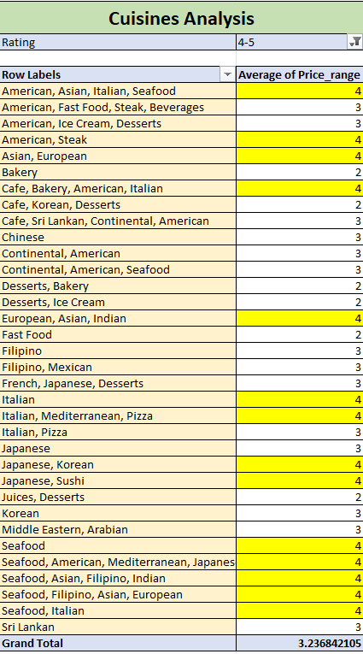**Decision** - By looking at the pivot table, I can see that particular cuisines, such Italian and seafood, are highly rated since they are popular in that nation. Based on the observation, it is decided that cuisine has an impact on the rating. Based on consumer input and preferences, these studies offer a foundation for comprehending trends and patterns in the data, enabling well-informed decisions and changes to be made in the restaurant industry.
* **Location :**Excel file - sheet name - **6) Cuisines-Analysis**

**7.  According to our current data, should we go for online delivery and table booking? Does that affect the customer’s rating?**

**Method used: -** I've utilized two pivot tables; I take reservations for tables in a row, rate them according to value, and then arrange them in order of average.   
My internet delivery is ranked by value, sorted by average, and delivered in a row.

* **Visualization method used** :- Pie chart shown below

**Decision -** We ought to order our food online and reserve a table. Since all restaurants, with the exception of Philippines, do not offer this service. This may provide us an advantage over rivals. However, in order to achieve this, we may conduct a study to find out whether or not citizens of that nation are open to ordering food online and reserving tables.

**Cost vs. Services**: Look into any connections between the price for two and the availability of delivery or table reservations. Examine whether consumers are prepared to pay extra for these services' convenience.

**Geographical Trends**: Examine whether there are regional or national differences in the availability of table reservations and delivery services.

**Location** -

          Excel file - sheet name - **7) Delivery - Analysis.**

**8. Should the team keep the rate of cuisines higher? Will that affect the feedback? According to our data are the rate of cuisines and ratings, correlated?**

**Method used:** I have determined the link between the rate of consumption and ratings using the CORREL Function.

**Formula Used**: =**CORREL (B13:B9563, C13:C9563)**

* **Decision**: We can keep the rate of cuisines higher, as the correlation is very negligible between rating and rate of cuisines.
* **Visualization method used** :- Scatter chart shown below
* **Location : Excel File - sheet named - 8) Correlation**

**9. What is the distribution of number of restaurants of different price ranges in all the countries?**

* **Method used**: Using a pivot table, I was able to arrange the restaurant name by value, price range by row, country by filter, and count by sorting.
* **Distribution of restaurant in different price range :**

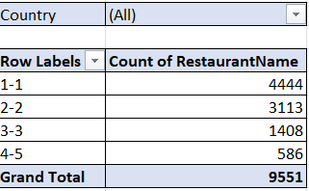

* **Visualization method used** :- Column chart shown below

* **Location** : **Excel File - sheet named : 9) Price-range**
* **Cell Reference in Dashboard :-**

****For this, I employed column (F, G) in the Excel file location's sheet 2 for the Country Description cell reference.

I did cell reference for this in excel file location- sheet 2) Country Description using column (J).



For this, I utilized column (M, N) in the cell reference for the country description on sheet 2 of the excel file.  
  
  
  
For this, I applied column (G, H) in my cell reference in the excel file position -3 (Object Analysis 3-6).

For this, I employed column (H, I) to do a cell reference in the excel file position -3 (Object Analysis 3-6).

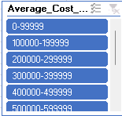

For this, I inserted column (AC) as a cell reference in the excel file location (sheet 4) Subjective-Analysis 1-4.